USER’S GUIDE

Through simple steps in our App you can find the shortest way between two SkyTrain Station.

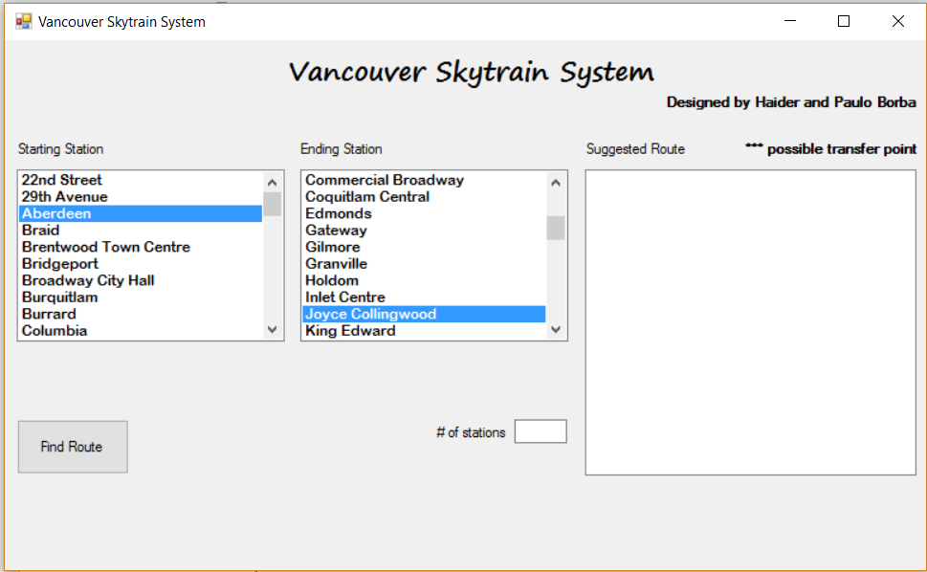First you need to select on left list called Starting Station (blue arrow), for this just press the left click above the name of the station where you will begin your trip, if you don´t find it at the first look, please left click and hold over the scroll bar (yellow arrow), then do the same steps to select your destination, now click on Find Route button (green arrow)

Ready, on the right side of the App a list (blue arrow) will present the route, and the “\*\*\*” (green arrow) marks indicates possible transfer point. The total station, including your starting and ending point will be present in the box # of station (yellow arrow).

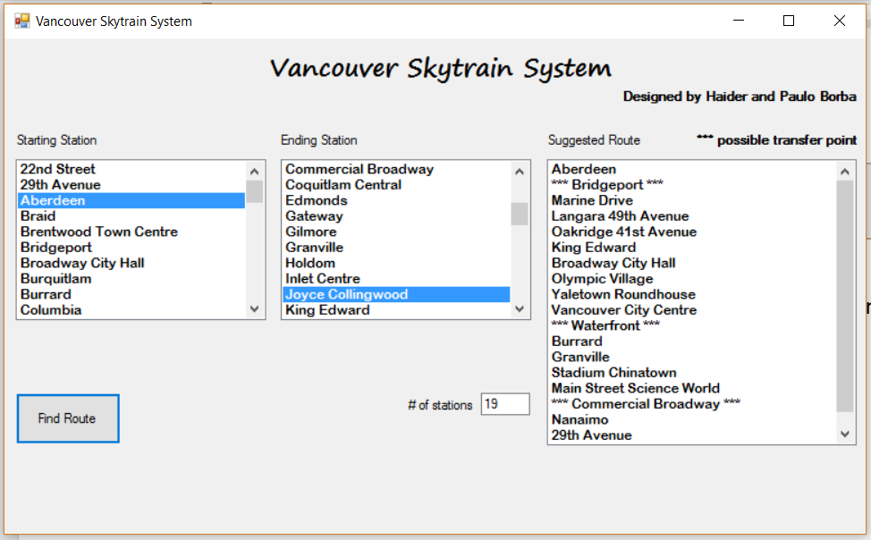

Ready, on the right side of the App a list (blue arrow) will present the route, and the “\*\*\*” (green arrow) marks indicates possible transfer point. The total station, including your starting and ending point will be present in the box # of station (yellow arrow).

You can re-do the research how many times you need, just repeating all the steps presented on this guide. For further information please contact us: [m.hassanhaider@hotmail.com](mailto:m.hassanhaider@hotmail.com) or [pcborba@yahoo.com](mailto:pcborba@yahoo.com) .